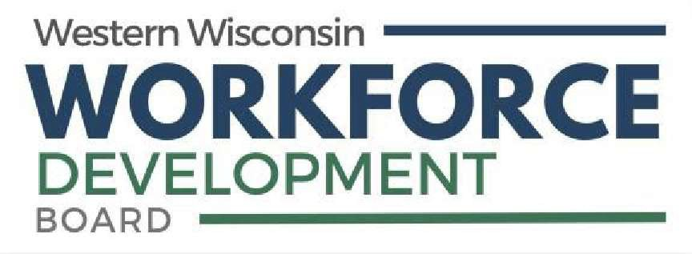
Workforce Innovation & Opportunity Act
(WIOA) Disability & Medical Disclosure
Applicant
Full Name:
8/28
Last First M.I.
The definition of disability:
have a physical or mental impairment that substantially limits one or more of their major life activities such as caring for themselves, performing manual tasks, seeing, hearing, eating, sleeping, walking, standing, lifting, bending, speaking, breathing, learning, reading, concentrating, thinking, communicating, working, and the operation of major bodily functions.
have a record of such impairment, OR
are regarded as having such impairment (which means they can establish that they have been the subject of a discriminatory action under the American with Disabilities Act because of an actual or perceived impairment, regardless of whether the impairment actually limits a major life activity).
Category of Disability (check all that apply)

No Disability
Physical/Chronic Health Condition Physical/Mobility Impairment Mental or Psychiatric Disability Do not wish to disclose
Vision-related Disability Hearing-related Disability Learning Disability Cognitive/Intellectual Disability

Services Received (check all that apply)

Received services from a State Development Agency (SDDA):
Received services from a State or Local Mental Health Agency (LSMHA):
Received services from a Home & Community Based Service Provider under a State Medicaid (HCBS) Waiver:
YES NO

YES NO

YES NO

Disability Work Setting:
Competitive Integrated Employment Individual Supported Employment Group Supported Employment
Sheltered Workshop
Combination of two or more settings Not Employed
Prefer not to answer
Type of Customized Employment Services Received:
Discovery Assessment Services
Developed a customized employment search plan Employer Negotiation Services
Employed result of customer employment services and external support services No CES services
Prefer not to answer

Received Disability Financial Capability:
Benefit Planning Services
Financial capability/asset development services Benefit plan/fin capability/asset development No
Prefer not to answer
Disability Individualized Education Program:
Current IEP Previous IEP
Prefer not to answer
Section 504 Plan:
Yes No

Pregnancy
YES NO
Are you currently pregnant?
Social Security Administered Funds

Do you or a family member receive Supplemental Security Income (SSI)?

Are you or a family member a Ticket holder for the Ticket to Work program?
I receive Family member receives Neither


Amount: I receive Family member receives Neither I am A family member is Neither
Do you or a family member receive Social Security Disability Insurance (SSDI)? $
per month

I attest that the information provided on this form is true to the best of my knowledge.

Signature: Date:

Babel Notice

In accordance with 29 CFR 38.9 (g)(3), Limited English Proficient (LEP) individuals seeking access to information about programs offered through the Western Wisconsin WDB and its American Job Center partners, will receive language assistance in all communications of vital information. Vital information is defined as information, whether written, oral, or electronic, that is necessary for an individual to understand how to obtain any aid, benefit, service and/or training; necessary for an individual to obtain any aid, benefit, service and/or training; or required by law. An interpreter, as well as the availability of free language assistance such as rulebooks; written tests that do not access English language competency, but rather assess competency for a particular license, job, or skill for which English proficiency is not required; and letters or notices that require a response from the beneficiary or applicant, participant or employee will be provided to all LEP individuals at no cost to the individual.
English IMPORTANT! There are documents that contain important information about training services; how to apply for training services; and your rights, responsibilities and/or benefits. It is critical that you understand the information in these documents. You can receive telephone translation assistance of all documents by calling (608) 789-4584 at no cost to you.
Español ¡IMPORTANTE! Hay documentos que contienen información importante acerca de los servicios de capacitación, cómo solicitar servicios de capacitación, sus derechos, responsabilidades y / o beneficios. Es fundamental que entienda la información de estos documentos. Usted puede recibir asistencia de traducción telefónica de todos los documentos por calling (608) 789-4584 sin costo alguno para usted.

Hmong TSEEM CEEB! Muaj cov ntaub ntawv uas muaj cov ntaub ntawv tseem ceeb txog cov kev pabcuam kev cob qhia; yuav ua li cas thov rau kev pabcuam kev cob qhia; thiab koj cov cai, lub luag haujlwm thiab / lossis cov txiaj ntsig. Nws yog ib qho tseem ceeb uas koj nkag siab cov ntaub ntawv hauv cov ntaub ntawv no. Koj tuaj yeem tau txais kev pab txhais lus hauv xov tooj ntawm txhua cov ntaub ntawv los ntawm kev hu rau (608) 789-4584 yam tsis tau them nqi rau koj.

Accommodation Requests
Auxiliary aids and services are available upon request to individuals with disabilities. Please contact your Child Care Specialist or the WWWDB office at (608) 789-4584 for such requests.

Wisconsin Relay (7-1-1)
Wisconsin Relay is a free service that provides full telephone accessibility to people who are deaf, hard-of-hearing, deaf-blind and speech-disabled. The service is available by dialing 7-1-1 or by calling TTY 1-800-947-3529. For more information, visit www.wisconsinrelay.com.

Equal Opportunity
Western Wisconsin Workforce Development Board is an Equal Opportunity Employer and Service Provider. Auxiliary aids and services are available upon request to individuals with disabilities. If you need this information interpreted to a language you understand or in a different format, please contact Tira Ferry, Equal Opportunity Officer, at 608-789-4584 or tira@westernwdb.org. Callers who are deaf or hearing or speech-impaired may reach us at Wisconsin Relay Number 711.

This workforce product was funded by a grant awarded by the U.S. Department of Labor’s (DOL)’s Employment and Training Administration (ETA). The product was created by the recipient and does not necessarily reflect the official position of the DOL/ETA. The Department of Labor makes no guarantees, warranties, or assurances of any kind, express or implied, with respect to such information, including any information on linked sites and including, but not limited to, accuracy of the information or its completeness, timeliness, usefulness, adequacy, continued availability, or ownership. This product is copyrighted by the institution that created it.

